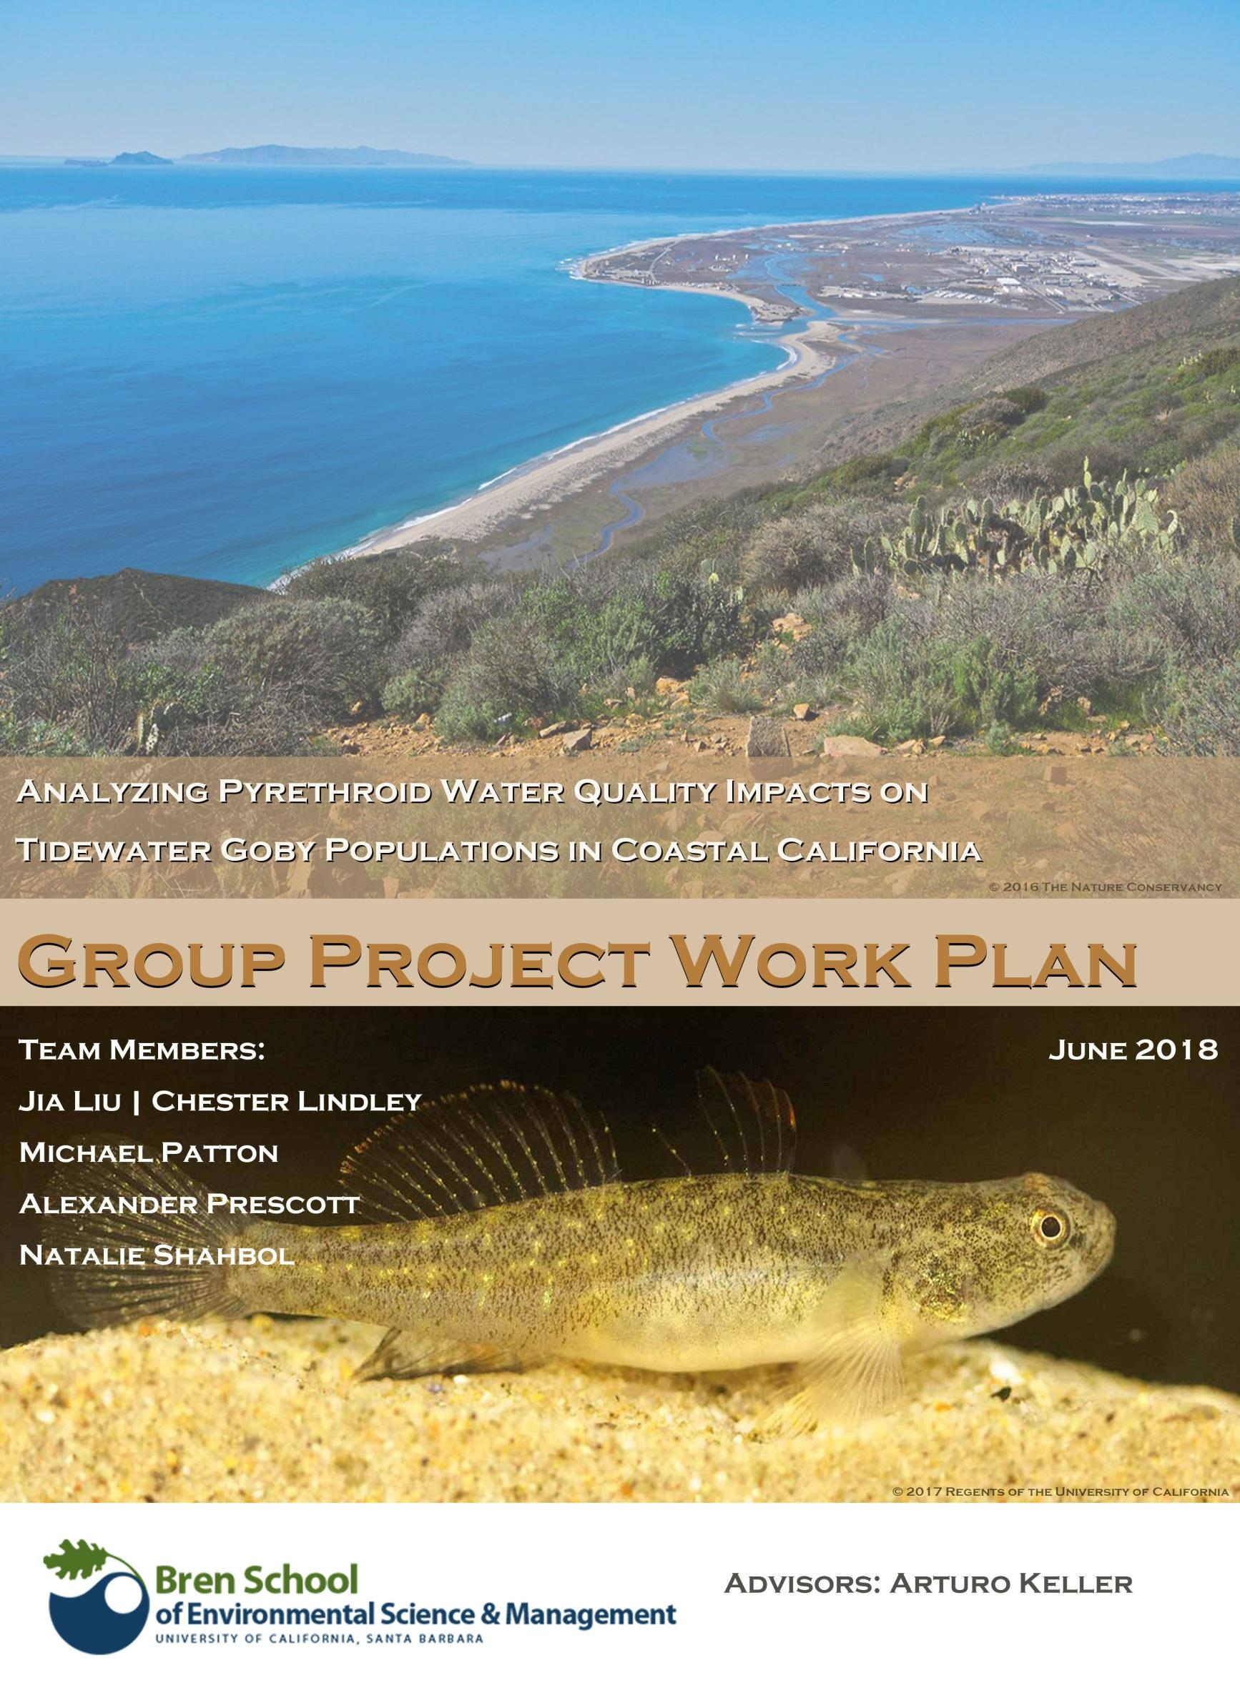

Table of Contents

1. Executive Summary 2
2. Objectives 3
3. Significance of the Project 3
4. Background 5
5. Literature Review 5
Ormond Lagoon and Proximal Area 5
Tidewater Goby 8
Pyrethroid Uses and Properties 11
Effect of Pyrethroids on Fish 15
Potential Effects of Pyrethroids on Tidewater Goby 17
6. Data Management Plan 21
7.Technical approach to solving the problem 23
8. Deliverables 26
9. Milestones 28
10. Management Plan 29
11. Budget 32
12. References 32

Executive Summary

Wetland ecosystems along the California coast have been decimated by development and land use changes since the early 1800s. Among the many challenges, inhabitants of these ecosystems face an emerging class of pesticides with an unknown potential for ecological damage. Pyrethroids, a synthesized compound modeled after the naturally occurring pyrethrins found in pyrethrum flowers, include a long list of extremely effective pest control substances that have substituted more hazardous and understood compounds. Pyrethroids are much less toxic to birds and mammals than their pesticide predecessors, yet are extremely lethal to aquatic invertebrates and fish species at levels on the magnitude of parts per trillion.

Although pyrethroids are hydrophobic, resulting in very low water solubility, they readily bind to organic compounds in soils, sediments, or particulate matter which can be transferred to coastal areas during rain, irrigation, or erosion events. Pyrethroids are fairly persistent in the environment and can accumulate in the sediments to toxic levels. In Southern California’s coast, the movement of pyrethroids into waterways and estuaries has already begun to wreak significant environmental damage. Fish kills producing thousands of dead fish have been linked to the presence of bifenthrin, an increasingly used pyrethroid for home ant control. Not only can pyrethroids have direct negative health impacts on fish, but by decimating invertebrate populations and sorbing to sediments, they can lastingly disrupt an entire food-web from the bottom up. A particular species of concern is the tidewater goby (Eucyclogobius newberryi and Eucyclogobius kristinae). These federally endangered fish thrive in brackish environments, feeding on invertebrates and constructing burrows in sediments to house their eggs and juveniles. The full effects of sediment-bound pyrethroid toxicity on the species remain unclear. Furthermore, as application rates increase and sediment bound levels accumulate, this knowledge gap becomes more pressing. As a result, U.S. Fish and Wildlife Services (USFWS) seeks to better understand the extent, magnitude, and potential impacts of pyrethroid contamination in the Ventura area, as well as the implications for regional and statewide species recovery.

To inform a species recovery plan, the Goby team will collect, compile, and analyze several datasets:
- Tidewater goby population size, distribution, and trends
- Pesticide toxicity, application forms, and annual riverine loads
- Presence of various sediment bound pyrethroids in Ormond Lagoon and other sites of interest
- Land use types and surface permeability within the watershed
- Best management practices (BMPs) for reducing pyrethroid runoff and environmental risk

The Goby Team will use findings from the aforementioned data research to tailor U.S Environmental Protection Agency (EPA) risk models to assess ecological risk associated with current pyrethroid application rates. In addition, a geospatial representation featuring the intersections between tidewater goby population distribution and environmental pyrethroid concentrations can help management bodies focus their effort on the most important or most threatened meta populations. The culminating deliverable of the Goby Team’s work will be a set of management recommendations. The Goby Team will synthesize findings into a guidance document that will formally evaluate pyrethroid pesticide use, provide possible reduction and mitigation efforts, and assess risks associated with continued pyrethroid use.

Objectives

The objective of this project is to assess the potential impacts of increasing pyrethroid pesticide use on the federally-endangered tidewater goby in Southern California’s coast. This project will utilize historic and current water quality and species presence data to develop a geospatial representation of pyrethroid concentration zones and tidewater goby populations. Additionally, students will implement EPA’s pesticide risk assessment model, using more exact local conditions to estimate the aquatic concentration of pyrethroids with certain application rates and the risk they pose to the tidewater goby and other fish populations near Ormond Beach Lagoon. Using concepts of conservation agriculture and green infrastructure, the Goby Team will formulate BMPs to reduce the off-site transportation of water and soil for pyrethroid application areas. Finally, this project will develop key management recommendations to relevant local, state, and federal agencies to reduce the threat of aqueous and sediment-bound pyrethroid pesticides to tidewater goby population viability.

Significance of the Project

Twice in the past two years, the Oxnard/Port Hueneme area has experienced fish kills, potentially linked to exposure to pyrethroid pesticides (California Department of Fish and Wildlife 2015; Jenny Marek, personal communication, 12 January 2017). Pyrethroids are a common and increasingly used class of agricultural and household insecticides (EPA 2016). Although significantly less toxic to humans and mammals than their organophosphate predecessors, pyrethroids are acutely toxic to aquatic species, particularly in the aqueous phase (EPA 2016).
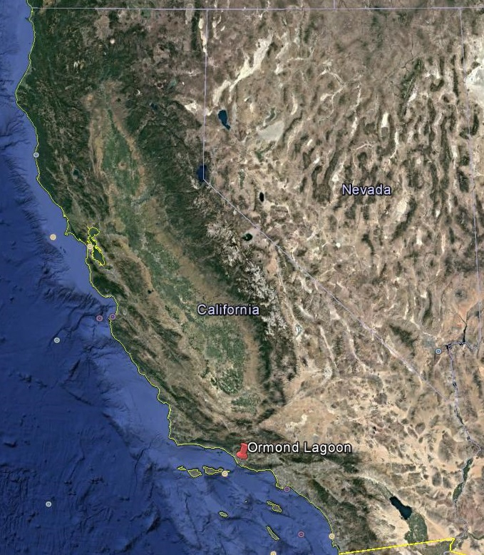
Figure 1. Ormond Lagoon, California. (Google Earth, 2017)

One such aquatic species of concern is the tidewater goby, a small, grey-brown fish found in estuarine waters along the California coast (USFWS 2014). Tidewater goby populations have been declining, largely due to habitat modification, water quality degradation, and drought, prompted the USFWS to list the species as “endangered” in 1994 (USFWS 2014). The recent fish kills in Oxnard/Port Hueneme occurred within or in close proximity to tidewater goby designated critical habitat at Ormond Beach Lagoon (Endangered and Threatened Wildlife and Plants; Designation of Critical Habitat for Tidewater Goby 2013). Furthermore, tidewater gobies spend considerable amounts of time burrowing in sediment, including vulnerable egg and juvenile stages. The full effects of sediment-bound pyrethroid toxicity on the species remain unclear and as sediment bound levels increase, this knowledge gap becomes more pressing. As a result, USFWS seeks to better understand the extent, magnitude, and potential impacts of pyrethroid contamination in the area, as well as the implications for regional and statewide species recovery.

In addition to the USFWS, the Ventura County Watershed Protection District, a manager of several drains discharging into Ormond Beach Lagoon, will benefit from a more thorough analysis of contamination and management considerations for this portion of critical habitat.
Nonprofit organizations following the management of tidewater goby recovery and water quality, such as the Center for Biological Diversity, Ventura Coastkeeper, and Santa Barbara Channelkeeper, may also benefit. Finally, residential and agricultural pesticide users— including homeowners, pest control companies, and agricultural landowners— can benefit from potential BMPs developed or recommended in conjunction with this project.

Background

The focus area for this project is Ormond Lagoon, California. Our work will contribute to a growing body of research on pyrethroid toxicity and contamination in tidewater goby range, including:

- A June 2011 U.S. FWS report on pyrethroid toxicity and early management considerations;
- A December 2012 Environmental Protection Agency bifenthrin risk report, which used Express (EXAMS-PRZM Exposure Simulation Shell) to develop Estimated Environmental Concentrations (EECs) for aquatic exposure of pyrethroid pesticides under various land uses and application rates/methods statewide;
- A September 2015 California Department of Fish and Wildlife loss report, determining pyrethroid toxicity as the cause of a July 2015 fish kill in Port Hueneme’s J Street Canal.

While there is prior and ongoing research on pyrethroid pesticide contamination and toxicity throughout California, the Goby Team will assist USFWS staff by providing a detailed, regional map of pyrethroid “hot spots” and generating EECs from the PRZM/EXAMS models using localized land use and pyrethroid application conditions for Ventura County.

Literature Review

Ormond Lagoon and Proximal Area

Site Overview
Ormond Lagoon, situated along the south coast of California in the city of Port Hueneme was once home to a complex and productive wetland ecosystem (Figure 2). However, due to extensive development and urbanization, Ormond Lagoon now has few and fleeting wetland habitats for remaining species. The surrounding land uses vary dramatically, but are dominated by agricultural, industrial, and residential developments. Ormond Lagoon is part of the 75% wetlands lost along the Southern California Coast due to development (California Coastal Conservancy 1999). In addition to the environmental stress of on-site land use changes, such as the conversion of wetland areas into recreational beaches, are industrial and agricultural impacts affecting Ormond Lagoon’s inflows. Directly adjacent to Ormond Lagoon is a defunct metal recovery smelter formerly operated by Halaco Engineering Company (Halaco), which has contributed toxic compounds to the lagoon through environmental negligence and mismanagement. Following Halaco’s bankruptcy in 2006, the complex was designated a Superfund site, and although some risk of further damage has been mitigated, significant quantities of hazardous materials remain on the premises.

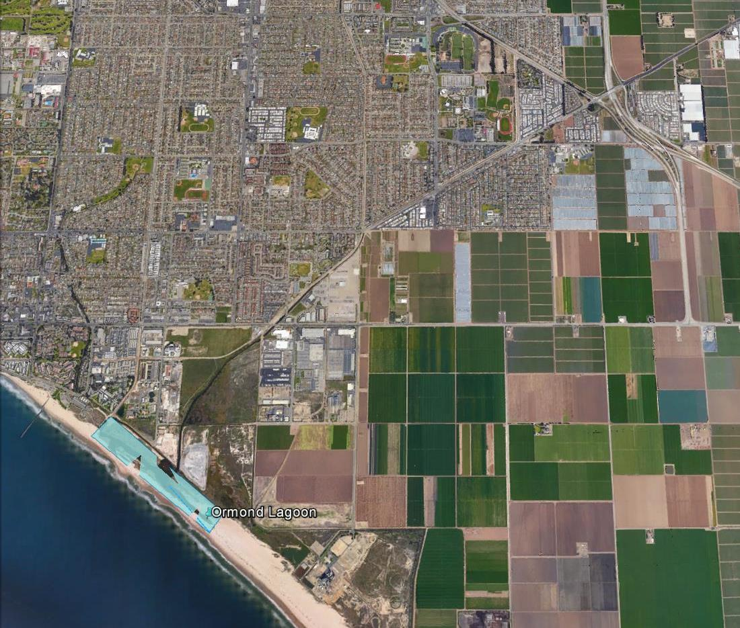
Figure 2. Ormond Lagoon, California. Surrounding areas have been fully developed with Industry, agriculture, and residential land replacing historic marshes and wetlands (Google Earth 2017).

Halaco Superfund Site, Heavy Metal Contaminants
Halaco operated a secondary scrap metal recovery facility from 1965-2004 encompassing over 11 acres of structures and 26 acres of waste deposition. Their processes recovered aluminum, magnesium, and zinc, from car parts, cans, castings, and other low grade scrap metal. An EPA diagnostic reports confirms that,
“Most waste remains on-site, including more than 700,000 cubic yards in the waste management area and an estimated 50,000 cubic yards buried in the eastern side of the 11-acre area where the smelter operated. Contamination found on-site includes a combination of several metals and radionuclides, including aluminum, arsenic, barium, beryllium, cadmium, chromium, copper, lead, magnesium, manganese, nickel, silver, zinc, cesium-137, potassium-40, thorium-228, thorium-230, and thorium-232. Contaminated soils and sediments containing one or more of the same metals and radionuclides have also been found on adjacent properties, including wetlands and a public beach. Several areas also contain elevated levels of thorium and radium. Waste material has moved into the underlying groundwater and sediments in a portion of the Ormond Beach lagoon.” (EPA 2017)
The recovery of the Ormond Lagoon wetland ecosystem is dependent on the remediation of the Halaco site. Further cleanup of the Superfund site and adjacent contaminated properties is expected to be planned in 2017 or 2018 (EPA 2017).

Fish Kill Events
Ormond Lagoon is partially fed by channelized drains such as the J-Street Drain, which receives agricultural, industrial, and residential runoff. Among the many pollutants carried by these drains are pyrethroids, a class of pesticides used for both agricultural and non-agricultural applications. The California Department of Fish and Wildlife has investigated multiple fish kill events related to a specific pyrethroid, bifenthrin. On July 20th 2015 U.S. Fish and Wildlife reported a fish kill in Port Hueneme’s J-Street Drain, which feeds directly into Ormond Lagoon. Although no tidewater gobies were found in the observations, this may be symptomatic of their small size, brown color, and lack of swim bladder. Included in their loss report is description of necropsy pathology,
“Bifenthrin was detected in each gill and liver sample. Bifenthrin is a synthetic pyrethroid insecticide with an LC50 of 0.35 ppb to bluegill sunfish (very highly toxic). While it is not possible to determine the concentration of bifenthrin in the water at the time of the fish kill, due to insufficient time for the contaminant to reach equilibrium in the fish and water, the presence of a very highly toxic material in both the gills and liver of fish that died acute death makes it very likely that this loss was caused by exposure to bifenthrin. The presence of 4 other pyrethroids in the gills of the sculpin is likely due to the persistence of pyrethroids in sediment and the sculpin being a benthic feeder.” (California Department of Fish and Wildlife, 2015)
Similar events in the watershed occurred in the years following, with another major fish kill occurring in 2016 (Personal Communication, Jenny Marek).

Tidewater Goby

Overview
The tidewater goby (Eucyclogobius newberryi and Eucyclobius kristinae) lives endemically along the coast of California. A typical tidewater goby has an elongated body with a length rarely exceeding 50 millimeters. (Miller and Lea 1972). Adult fish are translucent or mostly transparent, olive-brown with darker mottling (Miller and Lea 1972). The species shows narrow environmental preferences, mainly living in coastal lagoons, creeks, and marshes (Swenson 1999; Moyle 1976; Swift et al. 1989). Gobies feed on benthic invertebrates and burrow in the sand for spawning. The tidewater goby usually acts as the secondary consumer whose behavior may alter the population and structure of other organisms, especially their preys and predators. The species was listed as endangered in 1994 after a considerable decline in the population and the number of localities (USFWS 1994). Habitat loss or degradation, and pressure from introduced species threaten the survival of the tidewater goby. However, influences from other factors have also become more important recently. For example, water inflows to goby habitat may contain pesticides, which will settle and accumulate to toxic levels in benthic sediment.

Distribution and Habitat
The tidewater goby is distributed along California’s coastal lagoons, creeks, and marshes. (Swenson 1999; Moyle 1976; Swift et al. 1989). It has long been defined as species Eucyclogobius newberryi under genus Eucyclogobius. A recent study has shown tidewater gobies in the southern localities should be isolated from northern populations in taxonomy.
This new southern species is determined as Eucyclobius kristinae (Swift et al. 2016). The use of “tidewater goby” in this project covers research on both the Northern tidewater goby and Southern tidewater goby. The distribution of the two species “ranges from the Tillas Slough (mouth of the Smith River, Del Norte county) near the Oregon border to Agua Hedionda Lagoon (northern San Diego County)” (USFWS 2005).

Habitats of tidewater gobies are confined to major stream drainages where the topographic and hydrological features are conducive to the formation of sandy beaches (USFWS 2005). No populations have been found in streams without lagoons or estuaries present, while populations in marshes were observed to have larger size (Swenson 1996). The species can tolerate a relatively wide range of salinity and temperature. However, most of tidewater goby live in water with a salinity of 12 parts per thousand or less (Swenson 1999).

Life History
The life pattern of tidewater gobies is shaped by the annual or seasonal activities of their habitats (Swift et al. 1989; Swenson 1995; Swenson 1999). Generally, they migrate about 1 kilometer away from their living estuaries or lagoons into the upstream tributaries although some researchers have also found they could migrate 5 to 8 km away (Irwin and Soltz 1984). The migration of half-grown to adult gobies occurs in summer and fall (USFWS 2005). Researchers have proved this migration is closely related to reproduction.

The sexual behavior of the tidewater goby is unique among animals in nature as competition on mating happens among females rather than males (Swenson 1999). This reversed sex-role makes the tidewater goby serve as an ideal material to investigate the sexual selection. The reproduction of the tidewater goby can happen all year around. However, two peaks of spawning happen in the spring and the late summer (Swift et al. 1989). Suitable water temperature for reproduction is from 9 to 25℃, which limits the occurrence of reproduction during the colder winter months.

During spawning seasons, male tidewater gobies first dig burrows on the substrates for breeding. The Ideal substrate is clean coarse sand with a diameter of about 0.5 millimeter (Swift et al. 1989). Distance between two burrows is at least 70 to 100 mm (Swenson 1995). Male gobies will stay in the breeding burrows while female tidewater gobies compete exclusively to mate with males and lay eggs in the breeding burrows (Swenson 1999). The size of female gobies positively influences the amount of eggs per clutch (Swift et al. 1989). Generally, female tidewater gobies lay 300 to 500 per clutch and 6 to 12 clutches each year (Swift et al. 1989; Swenson 1999). Typically, those egg clutches stick on to the burrow walls around 2.5 centimeters deep (Swenson 1999). On average, eggs take 9 to 11 days to hatch, during which time the male gobies are responsible for guarding and caring for the egg clutches.

Hatchling gobies are approximately 4 to 5 mm. They are planktonic for 1 to 3 days, after which they begin a benthic life as adult gobies at a length of 16 to 18 mm (Swenson 1999). The juvenile tidewater goby usually reaches sexual maturity at about 27 mm (Swift et al. 1989). The lifespan of tidewater gobies is barely over one year (Moyle 2002) and the size is usually less than 50 mm. Researchers have found gobies collected in marsh habitats have larger sizes and can also live longer, compared to lagoons or creeks. (Swenson 1995; Swenson 1999). One of the probable causes for the higher growth in marshes is the stable conditions with less disturbance from winds and currents. Also, marsh ecosystems have plenty of food sources which promote the growth of tidewater gobies (Swenson 1999).

The diet of the tidewater goby consists of various benthic invertebrates. Optimal choices include ostracods, chironomid larvae, and the gammarid amphipod Corophium spinicorne. Other preys include polychaetes, oligochaetes, isopods, the gammarid amphipod Eogammarus ramellus, copepods, mysids, and invertebrate eggs (Swenson 1996). The diet of tidewater gobies may have both temporal and spatial variations depending on the seasonality of the different invertebrates.

Types of Habitats can also influence the diet. Tidewater gobies from marshes may include invertebrate eggs in their diet while gobies from lagoons and creeks may not (Swenson 1996). There is a significant diet overlap between juveniles and adults, which suggests an intense intraspecific competition when food is scarce (Magnhagen and Wiederholm 1982). High dietary overlap has also been observed between the tidewater goby and other small fishes, such as yellowfin goby and shimofuri goby (Kikuchi and Yamashita 1992).

Tidewater gobies are not strict day or night feeders, although adult gobies prefer to feed at night while juveniles show no preferences (Swenson 1996). As for the feeding behaviors, researchers have observed following three methods of foraging: sifting sediment for prey in their mouth, swimming to capture preys in mid-water, or biting prey at the substrate surface. Sifting sediment is a common way of feeding when no preys are clearly visible at the substrate surface. Gobies will first fill their mouths with sediments and filter them out through gill rakers (Swenson 1996).

Estimation of Population
Due to the wide range of variation in environmental conditions, it is hard to trace the population dynamics of the tidewater goby. It is normal to observe a decrease in the population when climate changes (e.g. El Niño) but a recover in the following year. The estimation of population size largely depends on the time and locations of sampling with different environmental factors. Tidewater gobies tend to extirpate and colonize habitats with some frequency following large storms that flush them out of their immediate habitat. But in general, the peaks and valleys of the population size occur in late summer-early fall and in winter, respectively (Lafferty et al. 1999a). Since directly acquiring the population size is difficult, scientists have developed some indirect methods by combining the number of tidewater goby localities and their frequency in each locality to estimate the population size (USFWS 2005).

After listing the tidewater goby as federally endangered species in 1994, USFWS implemented a Recovery Plan to ensure the sustainability of the species. Currently, USFWS is considering the downlisting of the tidewater goby from “endangered” to “threatened”. To meet the requirement of downlisting, metapopulations of tidewater gobies within each recovery unit must be predicted to have at least 75% probability of persisting in no less than 100 years. Therefore, an overall assessment of goby population status is essential to promote downlisting of the species. Researchers from UCLA have adopted a metapopulation viability analysis (MVA) model to assess tidewater goby population viability. Based on observed data (presence or absence of gobies in a region) and habitat characteristics (e.g. size, climate, water quality), the model will help predict patterns of extinction and colonization of a metapopulation.

Survival Stress
Current threats to the survival of the tidewater goby include habitat loss, changes of environmental properties, disease, predation, or competition from exotic species, and exploitation on the tidewater gobies. Due to the development along the coastal areas, direct loss and modification of habitats is the main cause of the decline in the population. Many favorable habitats have been drained for residential areas or faculties (USFWS 1994). Although some development projects did not destroy or reclaim the land of habitats directly, they have changed hydrological regimes or water quality (e.g. alter temperature or salinity), leaving the land unlivable for tidewater gobies (USFWS 2005).

Declines of the tidewater goby also stem from the introduction of invasive species (Swenson 1999). Tidewater gobies have a diet overlap with two invaded gobies species, yellowfin goby and shimofuri goby (Swenson 1999). Pressure from larger brackish or freshwater fishes is even more serious. Various localities of the tidewater goby have suffered from different nonnative predators. For example, striped bass (Morone saxatilis) at Waddell Creek lagoon, largemouth bass (Micropterus salmoides) at Old Lagoon, and Green sunfish (Lepomis cyanellus) at San Mateo Creek Lagoon have all been documented eliminating a population of tidewater gobies for a short period of time after invasion (D. Holland, pers.comm. 1992; Feldmuth and Soltz 1986; Swift et al. 1994).

Other survival stresses come from parasitism and exploitation of the fish for commercial or scientific use. Diseases caused by the fluke Cryptocotyle lingua, a common marine parasite have been discovered to infect tidewater gobies from Corcoran Lagoon and possibly Pescadero Lagoon (Swenson 1999; Swift et al. 1989). The infection of Cryptocotyle lingua can not only finally kill the host fish, but also make the host fish more vulnerable to predation. Juvenile fishes are particularly sensitive to the infection. Nevertheless, the parasitism of Cryptocotyle lingua is the only pathological impact on the population of the tidewater goby in records. Besides the disease, gobies are also harvested for commercial use or scientific researches, although it is not a major concern for the decline of the population (USFWS 2005).

Pyrethroid Uses and Properties
Ventura County is the 9th highest county in California in total pesticide use, applying 7,345,915 pounds of pesticide in 2015 (CDPR 2015; Figure 3). These applications are used both agriculturally (67% of total) and for urban or residential applications. Nonagricultural uses include fumigation, residential pest control, vector control, household products, and nursery applications.

A rising class of pesticides that have been applied more heavily in the past couple of years are pyrethroids. This is associated with the decline of organophosphate chemicals due to the concerns of their deleterious health effects. Pyrethroid pesticides are synthetic, organic compounds derived from the naturally occurring pyrethrins.

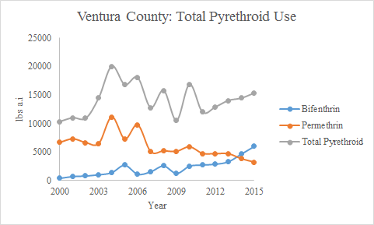
Figure 3. Total Pyrethroid Use in Ventura County. Bifenthrin, Permethrin, as well as total
pyrethroid use measured in pounds of active ingredients from 2000-2015. All data was
provided by the California Department of Pesticide Regulation (Adapted from CDPR 2015).

For Ventura County, the most commonly used pesticide of this class is bifenthrin. Bifenthrin is a pyrethroid compound synthesized for the control of a wide range of foliar insects, subterranean termites and wood infesting insects (Dong 1995). A total of 6,048 lbs active ingredient (a.i) was applied in 2015. The majority of the pesticide was used for structural pest control (55%) but strawberry production (26.7%) was also a heavy user of the compound (Figure 4).

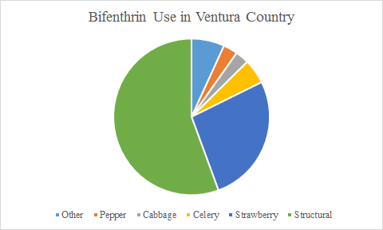
Figure 4. Percentage of the Uses for Bifenthrin in Ventura County for 2015. All data was provided by the
California Department of Pesticide Regulation (Adapted from CDPR 2015).

Bifenthrin has become popular for red imported fire ant control. This use has led to an increasing trend of Bifenthrin use in the non-agricultural sector since 2010 (Figure 5). Additionally, bifenthrin is becoming common in the household product marketplace. There are over 600 products containing Bifenthrin available in the United States, including sprays, granules and aerosols (Dong 1995). This has led to pesticide runoff in urban areas to become a major problem throughout California and the United States. In monitoring performed by the California Stormwater Quality Association (CASQA), Bifenthrin was detected in 69% of sediment samples and 64% of water samples (CASQA 2013).

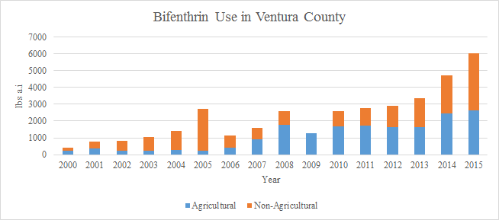
Figure 5. Total Bifenthrin Use by Agricultural and Non-Agricultural uses from 2000-2015. All data was provided by the California Department of Pesticide Regulation. Non-Agricultural uses were not collected in 2009 (Adapted from CDPR 2015).

Other pyrethroids used in our study area include (S)-cypermethrin, beta-cyfluthrin, cyfluthrin, cypermethrin, esfenvalerate, fenpropathrin, lambda-cyhalothrin, permethrin, pyrethrins, and tau-fluvalinate. According to CDPR, each one of these as well as bifenthrin was used in our study area during 2015 (Figure 6). Spatial Resolution for non-agricultural use is only provided at the county level so different data gathering techniques will be needed.

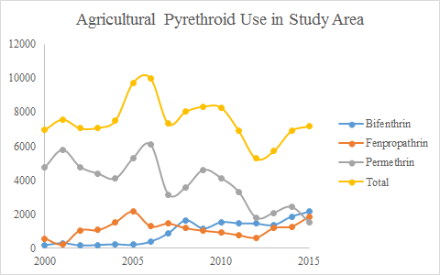
Figure 6. Agricultural Pyrethroid Use in Study Area. Note that this does not include non-agricultural pest control applications. All data was provided by the California Department of Pesticide Regulation (Adapted from CDPR 2015). For the preliminary data analysis, the Beardsley Wash, harmon Canyon-Santa Clara River, McGrath Lake-Frontal Pacific Ocean, Mugu Lagoon, and Revolon Slough-Calleguas Creek hydrological units were used to estimate the amount of pyrethroids used in the study area.

Chemical Properties
The environmental fate and transport of pyrethroids can be characterized by a strong affinity for soil and other organic material as well as strong environmental persistence (Table 1). The pyrethrins and synthetic pyrethroids are highly hydrophobic compounds that have an extremely low solubility in water. Pyrethroids have a high affinity to sorb to organic carbon in the soil, sediment, water, and dissolved particulate matter. This allows the pesticide to easily bind to sediment and be transported during erosion, irrigation, or runoff events. The synthetic pyrethroids are also resistant to degradation. The aerobic half-life values measured for bifenthrin is generally greater than 100 days (Fecko 1999). However the median aerobic soil half life for pyrethroids is about 23 days (Spurlock 2008). The bioconcentration factor for bifenthrin is high, therefore the compound is likely to bioaccumulate in aquatic species. Additionally, pyrethroids have a low volatilization potential and a very short atmospheric half-life. These properties allow pyrethroids to accumulate in the sediments; a potential problem for benthic species such as the tidewater goby.

Table 1. Chemical and Physical Properties of the Pyrethroids used in the Study Area. All data provided by CDPR unless otherwise indicated.
 | MW | Water Solubility (mg/L 25° C)ª | Kh (atm m³ mol) | Log Kow | BCF (bluegill sunfish)^{b} | Soil Adsorption Koc
Bifenthrin | 422.9 | 0.1 | 7.20E-03 | 6.00 | 6090 | 5.37
Cyfluthrin | 434.3 | 0.002 | 3.70E-06 | 5.74 | 719 | 4.80
Cypermethrin | 416.3 | 0.004 | 3.40E-07 | 6.60 | 597 | 5.49
Esfenvalerate | 419.9 | 0.006 | 1.40E-07 | 4.00 | 2390 | 4.00
Fenpropathrin | 349.4 | 0.014 | 6.30E-07 | 6.00 | 359 | 4.63
Cyhalothrin | 449.9 | 0.003 | 1.90E-07 | 6.90 | 2240 | 5.51
Permethrin | 391.3 | 0.006 | 1.40E-06 | 6.10 | 558 | 5.44
Pyrethrin | 372.4 | 125.6 | 7.40E-10 | 3.56 | 300 | 3.31
Flauvalinate | 502.9 | 0.002 | 3.05E-05 | 4.30 | 14000 | 6.04

a. USDHHS 2003
b. Laskowski 2002

Effect of Pyrethroids on Fish
The effects of pyrethroid pesticides on fish have been studied fairly extensively. While the pesticide is desirable because it is not toxic to mammals, it can have significant and often lethal effects on fish. While studies on the lethal and sub-lethal concentrations have not been explored for tidewater gobies, data for other species is informative.

Salmonids
Considerable research has been conducted on the impacts of pyrethroid pesticides of salmonids. In a study focusing on permethrin, the 96 h LC 50 for a 1-gram rainbow trout (Oncorhynchus mykiss) was 3.17 μg/L (Kumarguru & Beamish 1981). In this same study it was determined that both the size of a trout and the water temperature were inversely related to the lethal toxicity of permethrin. Larger trout, especially once they grow bigger than 5 grams are able to survive exposure to significantly higher concentrations of permethrin (Kumarguru & Beamish 1981). These findings could be important for management strategies for tidewater gobies. Tidewater gobies rarely grow larger than 55 mm and can live in water below 10°C (USFWS Recovery Plan 2005), which would potentially put them at risk to the similar pesticide concentrations and environmental conditions that affect rainbow trout.

In an early study of six different pyrethroids, rainbow trout and three other freshwater fish were exposed to different concentrations of pesticide. Researchers found that decamethrin was the most toxic, causing 90% mortality at concentrations of 1-2 ppb in all four species (Mulla et al. 1978). Other studies have shown different rates of mortality depending on the specific pyrethroid (Table 2). Different application rates and risk of pyrethroids to gobies will be an important consideration when analyzing pyrethroid use in California. Additionally, one of the species tested in this study was the mosquitofish, a similarly sized fish that feeds on invertebrates similar to the tidewater goby.

Table 2. Toxicity of studies for select pyrethroids in water on fish and invertebrates (Adapted from Anderson et al. 2010).
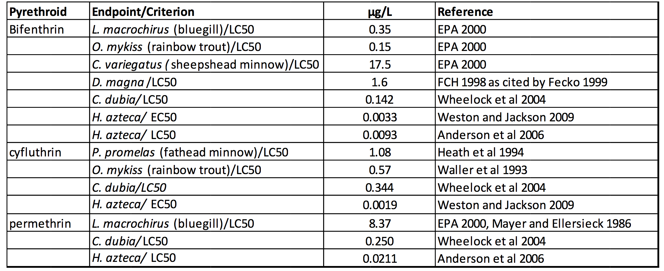

Pyrethroids can also adversely affect salmonids reproductive success. In a study using the pyrethroid fenvalerate, fertilized steelhead trout eggs and juvenile fish were exposed to intermittent or constant doses of pesticide. Steelhead eggs are laid in benthic environment like gobies. Steelhead embryos develop and eventually hatch from these eggs carrying partial sacs of egg yolk. At this stage they are known as alevins, or yolk-sac fry. Embryos and alevins exposed continuously to 80 ng/l of fenvalerate had a 90% survival rate after 8 weeks, but at concentrations of 135 ng/l, survival rate fell to 10% (Curtis et al. 1985). Pyrethroids pose a threat during early life stages, where a fish is most vulnerable, and could reduce the reproductive viability of species if exposure is consistent enough.

Another study conducted in the San Francisco Bay Delta looked at the effects of bifenthrin on gonadosomatic index (GSI) and hormones of steelhead. This study tested steelhead both in freshwater, saline, and hypersaline water, to look at habitats visited during steelhead reproduction. Researchers found that male steelhead GSI was significantly reduced after being exposed to bifenthrin in freshwater but not in saltwater (Forsgren et al. 2013). Female steelhead did not show decreases in the GSI. However, in the hypersaline conditions both plasma estradiol-17b and testosterone were significantly lower in female fish after being exposed to bifenthrin. These findings demonstrate the different impacts and numerous effects exposure to pyrethroids can have on fish reproduction.

Scorpaeniformes
Scorpaeniformes are one of the largest orders of bony fish, with over 1300 species classified in the order. A study focusing on sea ruffes, a fish in the rockfish family, also found pyrethroids negatively impacted reproductive ability of fish. Researchers exposed sea ruffes to three levels of bifenthrin for 50 days. Sperm in the groups of fish exposed to bifenthrin was significantly reduced (Li et al 2017). Levels of testosterone in fish exposed to 10ng/l and 100ng/l were also significantly reduced. These changes in sex hormone and sperm production could significantly reduce the reproductive success of fish.

Potential Effects of Pyrethroids on Tidewater Goby
Research on lethal concentrations and sublethal effects of pyrethroids on tidewater gobies is lacking. However, based on research explored about and an understanding tidewater goby behavior, we can speculate about how the pesticides may impact them.

Feeding
The diet of the tidewater goby is an important factor to take into account when looking for impacts of pyrethroids. A study of over 300 tidewater gobies found that they are specialist feeders that on occasion can feed opportunistically. The gobies eat benthic invertebrates and predominantly choose ostracods, chironomid larvae, and gammarid amphipods (Swenson & McCray 1996). Since pyrethroids are extremely hydrophobic they settle out into the sediment. In benthic environments the pyrethroids can remain for extended periods of time and come into contact with these invertebrates.

Studies in the Pacific Northwest have looked at pyrethroid presence in salmon streams and the effects on benthic invertebrates. In one of these studies, around one third of 35 streams sampled contained pyrethroids (Weston et al. 2011). This study sampled both urban and suburban streams and found bifenthrin was the pyrethroid of most concern. In another study in Northern California 32 of 33 urban runoff sites, and 12 of 18 Public Owned Treatment Works (POTWs) had pyrethroids, with bifenthrin again being the most prevalent (Weston et al. 2009). Both of these studies found to varying degrees that pyrethroid levels in benthic sediments reached acute toxicity for amphipods and chironomids. Toxicity to invertebrates was inversely correlated with temperature (Weston et al. 2011). In a study testing toxicity of lambda-cyhalothrin and cypermethrin in mesocosms, gammarid communities were completely wiped out while chironomids saw increases in populations (Farmer et al. 1994). Toxicity to benthic invertebrates could pose serious risk to fish, like the tidewater goby that rely on these sources of food. It will also be important to determine pyrethroid uptake rate from food, and the different responses among food sources to different types of pyrethroids.

Pyrethroid Best Management Plans
While there is growing concern over the potential impacts pyrethroids may have if they run off into waterways, research shows there may be management practices that could significantly reduce these risks. In a study in Salinas California, researchers analyzed storm water runoff from three urban sites with bioswales. Researchers collected water before it flowed into the bioswales, and water that was flowing out of the bioswales. When analyzing these water samples, they found that the bioswales reduced the presence of pyrethroids by 74% (Anderson et al. 2016). The significant reductions in pesticides observed during storm runoff demonstrate that bioswales could provide an important management tool in minimizing the damage of pyrethroids coming from urban areas.

There are a number of techniques that can slow down or prevent pyrethroids leaching from agricultural applications to sensitive locations. One of these methods is the use of field buffers to slow and direct the flow of sediment runoff. Since pyrethroids are hydrophobic and are present in sediment, controlling the flow of sediment runoff could be an important tool for directing runoff of pyrethroids. Field buffers also offer an opportunity to mitigate pyrethroids from reaching sensitive habitats. Creating a vegetated drainage ditch and placing it where runoff is directed from can stop the transport of pyrethroids. In a study focusing on lamda-cyhalothrin (Karate) in Mississippi, a 650 meter vegetated drainage ditch was created. Three hours after introducing this pyrethroid at the top of the ditch, 90% of the pesticide was captured from the drainage ditch water, 8% was captured in plants and 1% was captured in the sediment (Dabney et al. 2006). Sampling of outflow of the vegetated ditch showed that almost no pesticide reached the end of the ditch. This type of management technique could be implemented to contain pyrethroids and stop them from entering sensitive habitats.

Integrated Pest Management
Integrated Pest Management (IPM) is the use of various methods to achieve less pesticide use or risk. The University of California IPM Program more specifically defines it as “an ecosystem based strategy that focuses on long-term prevention of pest or their damage through a combination of techniques such as biological control, habitat manipulation, modification of cultural practices, and use of resistant varieties” (UC IPM 2016). These strategies can be used for both agricultural and non-agricultural pest management.

Non-agricultural
There are a variety of low toxicity IPM strategies and alternative materials for urban/structural pest management to reduce the risk of insecticide runoff. The most common is the reduction of the frequency of applications and the amounts of pyrethroids applied. UC Riverside Urban Entomology Department found that Pest Management Professionals could reduce pyrethroid applications by 75% and still provide cost-effective pest control (UC IPM 2016). This includes using modified application techniques such as pin-stream applications, spray free zones on hardscapes, limiting pesticide treatments to just structure foundations and the reduction of applications around impervious surfaces such as concrete (Greenberg 2010).

Alternative materials such as botanicals oils can be used for fire ant treatment, a heavy use for bifenthrin. This includes using 2-phenethyl propionate (derived from peanuts), thyme oil, or the natural pyrethrins instead of synthetic compounds such as bifenthrin. A study conducted by the Department of Entomology UC Riverside, found that monthly applications of botanicals compared to bimonthly use of more traditional insecticides controlled ants at about the same level. The same study also found that using bifenthrin granules instead of spray led to a significant decrease in runoff (Greenberg 2014). This study highlights the effect that small changes in pest management strategies in Urban settings can have on total bifenthrin runoff.

Agricultural
IPM practices are far ranging in their methods and have found various levels of success in the agriculture sector. This section of the literature review will focus on techniques that have been proven to reduce pyrethroid use on crops grown in the study area.

IPM techniques to reduce the prevalence of pests on strawberries includes controlling weed hosts in adjacent areas to the strawberry field, appropriately timed pesticide applications, choosing the right pesticide,as well as choosing the correct application medium (UC IPM 2016). Since the tidewater goby is affected when large amounts of pesticides are moved off site, water management practices can reduce the runoff of pesticides into critical habitat. This can include using drip irrigation, irrigation recirculation, and limiting total irrigation.

Since pyrethroids are mainly carried to surface waters sorbed to sediments during runoff events, various BMPs have studied reducing pesticide use during high runoff times. Currently the California Statewide Integrated Pest Management Project is promoting the replacement of the use of pesticides on almonds during the rainy season or winter in California with alternative practices (Epstein 2003). However, other studies have shown that winter applications of pesticides has some environmental advantages; including replacing multiple applications during the growing season, fewer adverse effects on beneficial arthropods, less exposure to field workers, and no exposure of fruit to potential residues (Epstein 2003). Further analysis is needed to see if this BMP is feasible for strawberry cultivation in Ventura County.

Erosion Reduction
Pyrethroids are highly hydrophobic, resulting in very low solubility in water and strong binding to organic compounds. This being said, when controlling the transportation of pyrethroids from agricultural applications to critical tidewater goby habitat, like Ormond Lagoon, limiting soil erosion and transportation is necessary. Conservation agriculture (CA) , “a set of of soil management practices that minimize the disruption of the soil's structure, composition and natural biodiversity. CA has proven potential to improve crop yields, while improving the long-term environmental and financial sustainability of farming” (Cornell University, 2015).

There are three main pillars included in CA: Permanent cover, crop rotation, and minimum soil disturbance. Although these practices serve to benefit many aspects of soil quality, effects related to soil erosion reduction are highlighted below.

Cover Crops
Maintaining a physical barrier above the topsoil surface is imperative to limiting erosion. Erosion of the soil via rain occurs initially on a minute level. Splash erosion is occurs when rain drops hit the soil surface, at speeds up to 20 miles per hour, throwing soil particles up to 5 feet horizontally and 2 feet vertically (Furbish, 2007). Smaller and lighter grains, such as fine clay particles necessary for nutrient sorption, are the first to be splashes and washed off site. Although this process has seemingly small effects, when distributed over a larger area the force of splash erosion is considerable. In addition to the direct force of the falling rain, is the surface flow or sheet wash effect. As water runs across a landscape, particularly on sloped parcels, fine soil particles are removed for the area. The combined effect of rainsplash and sheetwash erosion comprise 70% of down-slope erosion. The presence of a cover crop, with leaves deflecting the direct impact of rain and roots maintaining the integrity of the soil structure, can ensure the stability of the soil. Additionally, the presence of cover crops controls the growth of weeds, adds organic carbon to the soil, and increases soil porosity among many things. The choice of cover crop will depend on climate and soil needs, but is generally not a commercially viable crop. However, cover crops such as legumes offer increased nitrogen levels for the following crop harvest, improving yields.

Crop Rotation
Monoculture farming, the practice of growing a single variety of crop repeatedly on a given parcel, has significant negative effects on the soil chemistry. Both the physical reach and chemical demand varies from crop to crop. For example, overtime nutrients may leach down through the soil out of reach of the shallow root structures of corn. The deep roots of lima beans or squash can pump nutrients previously out of reach back within the range accessible by the corn. This rotation of crop can cycle nutrients, improving the growth of both cover crops and commercial crops. Crop rotations can include a mix cash crops to be sold in a market and cover crops that can be sued to protect the soil and increase soil fertility. A heterogeneous mix of crops ensure a well-mixed and stable soil structure that is less likely to erode. (Food and Agriculture Organization of the United Nations, 2015).

Tilling
Although the tilling of soil can improve the availability of soil nutrients and aeration in the immediate short term, structural degradation, loss of organic carbon, and soil compaction occur thereafter. Not only is the process of tilling soil costly in terms of time and energy requirements, but it also degrades the soil structure, requiring additional processes of fertilization and aeration.
The Agriculture and Consumer Protection Department of the United Nations states, “Soil tillage is among all farming operations the single most energy consuming and thus, in mechanized agriculture, air-polluting, operation. By not tilling the soil, farmers can save between 30 and 40% of time, labor and, in mechanized agriculture, fossil fuels as compared to conventional cropping.” Mechanized tilling violently churns the soil, which breaks roots, kills species important to soil health like worm and fungi, and alters the soil structure necessary for microbial nitrogen fixation (Food and Agriculture Organization of the United Nations, 2015). No-till farming can be accomplished successfully when the soil ecosystem is healthy, allowing the edaphon to aerate the soil naturally.

Data Management Plan

Describing the Research Data
There are several sources the Goby Team has collected data from or plans on gathering data from. Each section below gives a brief summary of each data resource, how to retrieve data, and the data format.

Surface Water Ambient Monitoring Program
Ambient water quality data are collected through California’s State Water Resources Control Board’s Surface Water Ambient Monitoring Program (SWAMP). This data are available in excel format through the California Environmental Data Exchange Network (CEDEN). Use the “Select Programs”, “Select Parameters”, and “Select Counties” to download data of interest for the Goby Team.

Ventura County Stormwater Permit
Ventura County Stormwater Permit data provide data on sites in Ventura County. A pyrethroid insecticides study was conducted in 2012 to establish a baseline data of pyrethroids for major watersheds in Ventura County, evaluate whether pyrethroid insecticide concentrations are at or approaching levels to be toxic to sediment-dwelling aquatic organisms, determine if pyrethroids discovered are from urban sources, and assess any trends over the Ventura County Municipal Separate Storm Sewer System National Pollutant Discharge Elimination System Permit. This data was converted from PDF document to excel to make it more accessible.

California Department of Pesticide Regulation
California Department of Pesticide Regulation (CDPR) provides pesticide application data from their Pesticide Use Reporting (PUR) program. These data are available in a wide variety of temporal and spatial scales.

Central Coast Ambient Monitoring Program
Central Coast Ambient Monitoring Program (CCAMP) data are available for download through the CCAMP website. Water quality, toxicity, metal concentration, organics, and nutrient concentrations can be found through CCAMP. Additionally, CCAMP can be a useful source for sampling methods, design, and analysis information for field work the Goby Team plans on conducting. Data are available in various forms on their website, but can also be retrieved from a contact at CCAMP in a more useful format, such as excel.

EPA EXPRESS Model (EXAMS and PRZM)
EXPRESS (EXAMS-PRZM Exposure Simulation Shell) is a two-tiered assessment of aquatic pesticide exposure for different geographic and agronomic settings. It combines the EXAMS and PRZM software. Exposure Analysis Modeling System (EXAMS) is an interactive computer software for formulating ecosystem models and evaluating the fate, transport, and exposure of synthetic organic chemicals. EXAMS software can be downloaded from EPA’s website. Pesticide Root Zone Model (PRZM) is a one- dimensional, finite-difference models that accounts for pesticide and nitrogen fate in the crop root zone.

Other Data Sources
There are other sources of data that are pending funding or the Goby Team is still in the process of finding. One source, pending funding, is goby and pyrethroid testing for LC50 for bifenthrin and other pyrethroids, which would be conducted by the UC Davis Granite Canyon Marine Pollution Laboratory, then shared with the Goby Team. Another source is through a UCLA student studying tidewater goby Metapopulation viability analysis (MVA). The Goby Team will likely collect water, sediment, or invertebrate samples which will be an additional source of data for analysis.

Data Standards
Gathered data will be stored as .pdf or .xls files in a central folder on Google Drive. A master copy of each data source received will be stored in the format they were received to avoid errors. Michael Patton and Natalie Shahbol will be responsible for ensuring that standards are applied and data are properly organized.

Metadata Standards
Gathered data will be grouped by technology in separate folders in the Drive. Data acquired through contacts will be noted to allow for questions to be easily answered as needed. The Goby Team’s contact information will also be stored so that questions on data can be answered if desired. In addition, variables, units, and any additional notes will be available for easy interpretation of data.

Data Sharing and Access
Data will be made available to the public unless otherwise requested by the source. ArcMap, Microsoft Office, and other software used for EPA Modeling data will be required to open some files.

Intellectual Property and Reuse
Any data created by the Goby team will be assigned a Creative Commons license to allow for usability and accessibility for the future. When data are acquired from an external source, the Goby Team will inquire about redistribution rights to ensure compliance with the scientific community and the law.

Data Archiving and Presentation
All final products and data will be stored and archived on Bren Network Provided Drive. . Only data necessary to replicate the Goby Team’s work will be archived.

Technical approach to solving the problem
The overall goal of this project is to determine the impact of pyrethroid pesticide on tidewater goby populations. The Goby Team will analyze and develop management strategies to minimize risk to associated with pyrethroids. The management strategies provided will be in the form of readily applicable best practices and project proposals to better support and protect tidewater goby critical habitat. The following approach expands on the Goby Team’s stated objectives and systematically details steps necessary to produce analysis and recommendations for pyrethroid impacts on tidewater goby populations in the region of study.

1) Perform Data Collection, Compilation, and Analysis

Evaluate tidewater goby species population data
To evaluate the tidewater goby population, the Goby Team will collaborate with USFWS partner Brenton Spies. He maintains an unpublished dataset with tidewater goby presence recordings for nearly 300 coastal California locations. Recordings date back to the 1800s and become much more robust following 1990s. Over the summer months of 2017, Brenton and members of the Goby Team will conduct field work to update the presence dataset. This may prove to be a very important year of record due to this year’s abundance of rain, making goby habitat recolonization possible. Detailed accounting of colonization and extirpation will allow the Goby Team and Brenton to identify source and sink populations. Identifying source populations allows the Goby Team to make specifically tailored and perhaps more stringent preservation recommendations for habitats of special importance.

Evaluate Pesticide Use around Ormond Lagoon
In order to evaluate impacts of pyrethroid pesticide use in Ormond Lagoon, the Goby Team will collect data from the Surface Water Ambient Monitoring Program, Ventura County Stormwater Permit, and California Department of Pesticide Regulation. This will include water quality data and pesticide application loads when applicable. The Goby Team will primarily assess the dynamic application rates and water loads of pyrethroids such as bifenthrin and permethrin, but will also examine other major pesticides used in the area which as of 2015 may include chloropicrin, fipronil, or chlorpyrifos. This step will heavily rely on the Pesticide Use Reporting (PUR) data required for all agricultural pesticide applications which can be paired with agricultural land use around the study area. Sediment bound concentrations of pyrethroids have been analyzed sparingly in the area and the Goby Team is likely to complete additional assays to inform our research and recommendations. To capture the full range of pesticide applications, non-agricultural uses will also be examined, such as the use of bifenthrin as a urban pest control chemical. Since these applications are not included in the PUR protocols, different techniques will be needed to estimate the urban and residential pyrethroid use. This may include using annual sales data, surveying Certified Pest Management Practitioners or other statistical extrapolations.

Develop a geospatial representation of the tidewater goby range as well pyrethroid concentration areas of concern
Using the aggregated data, the Goby Team will develop a geospatial document highlighting areas of concern for pyrethroid concentration and compare this to the known population ranges of the tidewater goby. This geospatial representation will rely on data about local extirpation and colonizing populations. These data will be acquired from Brenton Spies, who has extensive information about the presence of tidewater gobies spanning the length of California going back to the 1970s. These goby population data will then be compared to known areas of pyrethroid use. The final product of this step will be completed on ArcGIS.

Use the EPA EXPRESS model to estimate any risk to the Tidewater Goby
The Express (EXAMS-PRZM Exposure Simulation Shell) is a tiered model developed by the Environmental Fate and Effects Division of EPA’s Office of Pesticide Programs to determine the appropriate level of modeling needed to perform a pesticide risk assessment. The tier method is designed to screen out pesticides by requiring higher levels of investigations for each tier that does not pass the previous tier. “Passing” an assessment indicates that the pesticide has a low risk probability to the environment, while “failing” as assessment indicates that the pesticide is either has a high risk likelihood to the environment or must go through the next higher assessment tier. The purpose of this tiered model is to produce a thorough analysis and create a better understanding of which pesticides should be targeted in a given area.

This two-tiered model is based on the combination of two dynamically linked models: Pesticide Root Zone Model (PRZM) and Exposure Analysis Modeling System (EXAMS). PRZM is a one-dimensional model used to simulate chemical movement in unsaturated soil systems within and immediately below the plant root zone. Each PRZM simulation represents a variation of climatic conditions, crop-specific management practices, specific soil properties, site-specific hydrology, and pesticide-specific application and dissipation processes. Each simulation uses historical data to provide a probabilistic exposure for a single site over several years (generally 30 years). EXAMS “contains a set of process modules that link fundamental chemical properties to the limnological parameters that control kinetics of fate and transport of chemicals in aquatic ecosystems” (Burns 2007; Burns et al. 1982; Burns and Cline 1985). It accounts for subsequent transport, volatilization, sorption, hydrolysis, biodegradation, and photolysis of the pesticide. The PRZM-EXAMS generates single-day peak concentration, the maximum 24-hr, 96-hr, 21-day, 60-day, and 90-day mean concentrations, and mean annual concentration for pesticides from multiple-year concentrations from water column and benthic sediments. Overall, the PRZM-EXAMS model combines the chemical properties of the pesticide as well as physical data for the area to estimate the risk of a pesticide on ecological and human health.

The Goby Team will rely heavily on the EPA guidance documents and input more localized conditions for the study area. The model will be simulated to find the risk of 10 classes of pyrethroids (as mentioned in the literature review) use in the study area on the tidewater goby. The following data are needed:
- PRZM Chemical Parameters: This includes various chemical properties for pyrethroids. These have been either found empirically or estimated in previous EPA studies.
- EXAMS and Environmental Fate Parameters: This includes any transformative processes that pyrethroids experience in the environment, the spatial distribution of the pyrethroids in the aquatic ecosystem, and persistence of the pyrethroids. These values can be gathered from previous EPA studies from the EPA’s website.
- PRZM Application Data for Pesticide Use Patterns: This will require gathering data on the various pyrethroid uses in the study area. Much of this data are provided by CDPR.

2) Identify and evaluate strategies for pyrethroid pesticide use reduction and mitigation of its effects on the Tidewater Goby for the Ventura Area.
Review formal literature and existing studies
The goal of the literature review will be to compile information relevant to pyrethroid pesticide use and reduction. From the Goby team’s research on pyrethroid pesticide use reduction, different strategies will be evaluated for effectiveness. Additionally, information of pyrethroid mitigation and its effects on the tidewater goby will be evaluated for the Ventura Area. Research and compilation from existing studies will be used as template and starting point identifying effective strategies.

Identify feasible pyrethroid management strategies for reduced use and smaller effects on the tidewater goby
From the literature review findings, the Goby Team will evaluate the feasibility for mitigation efforts and pyrethroid pesticide reduction strategies for the Ventura Area. Specifically, identifying the feasibility of reducing pyrethroid pesticide impacts of the tidewater goby. The Goby Team has begun to explore BMPs for reducing the likelihood that pyrethroids will run off from application sites, and measures that can be taken to prevent them from entering sensitive habitat. The Goby Team will also research pesticide use, and techniques that are currently utilized to reduce the quantity of pesticide used in both home and agricultural applications. Coupled with the literature findings, the Goby Team will incorporate results from the PRZM/EXAMS model to provide informed management strategies.

3) Develop our recommendations for pyrethroid management into a guidance document.
Lastly, the Goby Team will synthesize findings from each objective listed into a well-organized and professional guidance document. The document will scientifically evaluate and identify pyrethroid pesticide uses and mitigation efforts to minimize the risk of species loss. Findings will be made available to relevant management bodies and shared with USFWS.

Deliverables

Beyond a final written report, policy brief, poster, and oral presentation, the group will provide:
- A geospatial representation of pyrethroid contamination in regional waterways of relevance to tidewater goby recovery.
- Results of a PRZM/EXAMS analysis using local water quality, pesticide use, and land use data in the Oxnard/Port Hueneme area;
- Management recommendations for minimizing negative impacts of pyrethroid contamination. Potential recommendations include pesticide application rates and protocols, best management practices, stormwater treatment strategies, and critical habitat maintenance.

Additionally, this project will fulfill academic requirements necessary to complete each quarterly course towards earning the MESM degree. The class code, timing, and necessary deliverables are included below.

ESM 401A (Spring 2017)
Scoping of the Project: Through clear and frequent communication with our client and advisor, our team developed the collective understanding of the project proposal into a more fully realized endeavor.
Work Plan: The culmination of the group’s progress thus far, the work plan is a concrete and realistic statement of what the group will do to the solve the assigned problem for the client. The report will include significant articulation of the project’s specific challenges, requirements, and goals.
Work Plan Review: Collaboration with and guidance from our academic advisors, external advisors, and clients allow our team to digest constructive criticisms and refine the quality and accuracy of our work pan.
Website: Establishing an online presence allows our team to more easily share our personal and project related information. This will be updated regularly to reflect the current state-of-affairs and will provide a lasting record of our team’s efforts.

ESM 401B (Fall 2017)
Fall Progress Review Meeting: This meeting between all associated parties allows our team to update our clients on the progress of the project. Significant data analysis and figure design will occur in the quarter and this meeting will be timed to allow for post-meeting adjustments, should they be necessary.

ESM 401C (Winter 2018)
Draft Final Report: The final report is a complete discussion of the project’s objectives, significance, methodologies, results, and accomplishments. A high quality draft of the final report must be completed by mid-winter quarter (before the group’s defense) and the final report is due at the end of winter quarter.
Project Defense: The team will present our analytical approaches and findings to Bren faculty, staff, and students for their review. This is an opportunity to clarify deliverables and refine our communication.

ESM 401D (Spring 2018)
Project Brief: This succinct report will serve to inform to non-expert individuals about the importance of the project, the problem specifics, and the recommended solutions.
Project Poster: A large and unique poster will convey the full scope of the project in an approachable and engaging matter.
Final Presentation: Master’s Project final presentations celebrate the completion of innovative, leading edge research and offer the opportunity for Bren MESM students to share their work with faculty, peers, potential employers, members of the community, family and friends.
Website: Creation and maintenance of the website is in progress.
Data and Metadata: Data used in the project and associated metadata must be archived and made available through the Bren School and UCSB Library.

Milestones

Spring Quarter 2017:
Friday, May 12th | Project work plan submitted to Faculty Advisor, External Advisors, and Client
Friday, May 12th | Finish literature review, organize available data
Friday, June 2nd | Finish all major designs of the website
Thursday, May 18th | Field trips to interested areas and summarize findings

Fall Quarter 2017:
Monday, October 2nd | Progress Report submitted Faculty Advisor
Thursday, October 19th | Take samples in fields, investigation & analysis on samplings

Winter Quarter 2018:
Monday, February 12th | Draft of Final Report submitted to Faculty Advisor
Early March | Project Defense
Late March | Final Report submitted to GP Coordinator

Spring Quarter 2018:
April | Presentation of Project to the Public
May | Recommendations submitted to Client

10. Management Plan

Group Member Roles & Responsibilities:
Role | Name | Responsibilities
Faculty Advisor | Arturo Keller | Meet weekly with students & attend review meeting; Provide feedbacks and assign grades to students
External Advisor | Lindsay Griffin | Attend spring and fall review meeting & give feedbacks on final report or other deliverables
Project Manager | Alexander Prescott | Compile meeting agendas;  Ensure the work is divided up among group  members & completed on time; Resolve group  conflicts; Assure that Project Objectives are met
Data Managers | Michael Patton, Natalie Shahbol | Assure that all data provided by client &  collected by group is organized & easily  accessible in Google Drive; Resolve data  management issues
Financial Manager | Chester Lindley | Compile project budget; Maintain records of group spending; Recommend strategies  that will help adhere to budget
Outreach Manager | Jia Liu | Create, update, and maintain group website

Meeting Structures
Meetings for the spring quarter will be bi-weekly, a student only meeting on Monday’s at noon, and a meeting with Arturo Keller at 5pm. Meeting times are subject to change and will likely do so in the coming quarters as schedules change due to course offerings. Meeting times will be chosen to facilitate optimum attendance and productivity. For all meetings Alexander will reserve a meeting room and outline the action items. Natalie will take the notes and make them available for the team immediately following the meetings. The project manager will also lead the discussion, calling on members to summarize their findings and ensure all task items are addressed in a timely manner.

Interacting with clients, faculty advisor, and external advisors
Meetings with faculty advisor are on Mondays at 5pm for Spring Quarter 2017. Alexander will summarize any relevant updates with questions collected from other group members and report them to faculty advisor. Feedback from faculty advisor will be considered to improve the group work through the next week. Clients will provide any accessible data and contact information related to the project. Meetings with clients are scheduled through email. Drafts and finalized reports/deliverables will be submitted to clients for their review. Meetings will be held quarterly or bi-quarterly to facilitate good communication. External advisors are contacted mainly through emails and phone calls when appropriate. Additional meetings with external advisors, academic advisors, or clients may be scheduled by Alexander if necessary.

Procedures for documenting, cataloging and achieving information
All documents are cataloged into folders with a descriptive name on Google Drive. Data managers are responsible for updating and filing data downloaded from various platforms. Data are filed into folders by the source. Each group member compiles a document that summarize the findings from literature reviews. Links or full documents of references are shared within the group. The Goby team has also been provided access to an on-campus UCSB Bren shared drive, to hold the team’s documents, data, and software.

Group Member Expectations
All group members are expected to adhere to the following guidelines:
- Attend and participate in all group meetings, allowing for properly communicated conflicts.
- Complete all assigned tasks by their respective deadlines, and will alert other group members if the work will not be completed by the due date
- Respond positively and professionally to clients, advisors, or other people associated with the project to promote good working relationships.
- Review meeting notes and promptly communicate any unclear objectives or tasks.
- Address personal or project conflicts within the team in person.
- Produce high‐quality work accomplished through appropriate application of effort.
- Fulfill all the academic and professional goals of the project.

Conflict resolution process
All members have agreed to bring all disagreements, frustrations, or concerns to the attention of the relevant project team members in question. If a task assigned to any group member is more difficult or complex than previously thought, it should be brought to the attention of the team quickly and explicitly.

If a satisfactory solution cannot be agreed upon within the group, the project manager will bring the problem to the attention of the faculty advisor. For a task which is regarded to be impossible to finish by June 2018, the group will re-focus the project under the guidelines of advisors. When the group fails to finish goals with the time limit, the group will engage the faculty advisor or the Group Project Coordinator. The project manager will meet individually with the faculty advisor and/or the Group Project Coordinator to find solutions if a group member consistently fails to finish assigned tasks. When encountering serious and urgent problems, all group members will feel free to schedule individual meetings with faculty advisor and/or Group Project Coordinator.

11. Budget

Projected Budget
Item | Projected Cost
Poster Printing | $400.00
Briefs | $250.00
Travel to Oxnard | $220.00
Visitor Parking | $30.00
Meeting Food | $50.00
Conferences | $200.00
Sampling | $150.00
Total | $1300

12. References

Agricultural and Natural Resources, University of California. Strawberry Year-Round IPM Program, Statewide Integrated Pest Management Program. May 2010. Retrieved From:
http://ipm.ucanr.edu/PMG/C734/m734yi01.html#PESTAPP

Anderson, B., B. Phillips, J. Hunt, K. Siegler, J. Voorhees, K. Smalling, K. Kuivila, M.
Adams. (2010). Watershed-scale Evaluation of Agricultural BMP Effectiveness in Protecting Critical Coastal Habitats: Final Report on the Status of Three Central California Estuaries. U.C. Davis, Granite Canyon and U.S. Geologic Survey. Grant Report for the Central Coast Water Board. April 30, 2010.

Anderson, B. S., Phillips, B. M., Voorhees, J. P., Siegler, K., & Tjeerdema, R. (2016). Bioswales reduce contaminants associated with toxicity in urban storm water: Bioswales treat urban storm water. Environmental Toxicology and Chemistry, 35(12), 3124–3134. https://doi.org/10.1002/etc.3472

Burns, L.A. (2007). EXAMS-PRZM Exposure Simulation Shell: User Manual for EXPRESS. National Exposure Research Laboratory, Ecosystems Research Division, US Environmental Protection Agency.

Burns, L. A., & Cline, D. M. (1985). Exposure Analysis Modeling System: Reference Manual for EXAMS II. Environmental Research Laboratory, Office of Research and Development, US Environmental Protection Agency.

Burns, L. A., Cline, D. M., & Lassiter, R. R. (1982). Exposure analysis modeling system (EXAMS): User manual and system documentation (p. 30613). Environmental Research Laboratory, Office of Research and Development, US Environmental Protection Agency.

California Coastal Conservancy. (1999). The First Year Report (No. 1). Retrieved from http://www.scc.ca.gov/webmaster/ftp/pdf/bayreports/first_year_report.pdf

California Department of Fish and Wildlife, (2015). Pesticide Investigations. Wildlife Investigations Laboratory.

California Department of Fish & Wildlife. (2015). J-Street Drain Fish Loss, 9-2015 (Wildlife Investigations Laboratory Pesticide Investigations). Port Hueneme.

California Department of Pesticide Regulation. 2015. Pesticide Use Reporting. Statewide Reports years 2000 through 2015. Available at http://www.cdpr.ca.gov/docs/pur/purmain.htm. Accessed April 20th, 2017.

California EPA State Water Resources Control Board, Surface Ambient Monitoring Program (SWAMP). 5-10-16 Retrieved from:http://www.waterboards.ca.gov/water_issues/programs/swamp/spot

Casjens, Heather. Environmental fate of Cyfluthrin. Department of Pesticide Regulation, Environmental Monitoring and Pest Management Branch. Sacramento, California.
http://www.cdpr.ca.gov/docs/emon/pubs/fatememo/cyflthrn.pdf

Conservation Agriculture: Global Research & Resources. (2015). Retrieved from http://conservationagriculture.mannlib.cornell.edu/

Curtis, L. R., Seim, W. K., & Chapman, G. A. (1985). Toxicity of fenvalerate to developing steelhead trout following continuous or intermittent exposure. Journal of Toxicology and Environmental Health, 15(3–4), 445–457. https://doi.org/10.1080/15287398509530671
Dabney, S. M., Moore, M. T., & Locke, M. A. (2006). Integrated Management of in-Field, Edge-of-Field, and After-Field Buffers1. JAWRA Journal of the American Water Resources Association, 42(1), 15–24. https://doi.org/10.1111/j.1752-1688.2006.tb03819.x

Dong, Michael H., Human Pesticide Exposure Assessment: Bifenthrin. Department of Pesticide Regulation California Environmental Protection Agency. July 14, 1995 Retrieved from: http://www.cdpr.ca.gov/docs/whs/pdf/hs1722.pdf

Dunne, T. (2010). A rain splash transport equation assimilating field and laboratory measurements. Journal of Geophysical Research, 115(F1). https://doi.org/10.1029/2009JF001302

Endangered and Threatened Wildlife and Plants; Designation of Critical Habitat for Tidewater Goby, 78 Fed. Reg. 8746 (February 6, 2013) (to be codified at 50 CFR Part 17). Retrieved from: https://www.gpo.gov/fdsys/pkg/FR-2013-02-06/pdf/2013-02057.pdf

Epstein, Lynn, and Susan Bassein. "Patterns of pesticide use in California and the implications for strategies for reduction of pesticides." Annual review of phytopathology 41.1 (2003): 351-375.

Farmer, D., Hill, I. R., & Maund, S. J. (1995). A comparison of the fate and effects of two pyrethroid insecticides (lambda-cyhalothrin and cypermethrin) in pond mesocosms. Ecotoxicology, 4(4), 219–244. https://doi.org/10.1007/BF00116342

Fecko, A. (1999). Environmental fate of bifenthrin. Department of Pesticide Regulation, Environmental Monitoring and Pest Management Branch. Sacramento, California

Feldmuth, R. and D. Soltz. (1986). Biological Survey of San Mateo Lagoon.
Report to Marine Corps Base Camp Pendleton.

Forsgren, K. L., Riar, N., & Schlenk, D. (2013). The effects of the pyrethroid insecticide, bifenthrin, on steroid hormone levels and gonadal development of steelhead (Oncorhynchus mykiss) under hypersaline conditions. General and Comparative Endocrinology, 186, 101–107. https://doi.org/10.1016/j.ygcen.2013.02.047

Furbish, D. (2007). What is rain splash erosion and why is it important? Retrieved from http://www.vanderbilt.edu/exploration/text/index.php?action=view_section&id=1104&story_id=268&images=

Greenberg, L., Rust, M. K., Klotz, J. H., Haver, D., Kabashima, J. N., Bondarenko, S., & Gan, J. (2010). Impact of ant control technologies on insecticide runoff and efficacy. Pest management science, 66(9), 980-987.

Greenberg, L., Rust, M. K., Richards, J., Wu, X., Kabashima, J., Wilen, C., ... & Choe, D. H. (2014). Practical Pest Management Strategies to Reduce Pesticide Runoff for Argentine Ant (Hymenoptera: Formicidae) Control. Journal of economic entomology, 107(6), 2147-2153.

Gunasekara, Amrith S. (2005). Environmental fate of Pyrethrins. Department of Pesticide Regulation, Environmental Monitoring and Pest Management Branch. Sacramento, California
http://www.cdpr.ca.gov/docs/emon/pubs/fatememo/pyrethrin_efate2.pdf

Halaco Superfund Site. (2017). Retrieved from https://yosemite.epa.gov/r9/sfund/r9sfdocw.nsf/ViewByEPAID/cad009688052

Holland, D. (1992). The distribution and status of the tidewater goby (Eucyclogobius newberryi) on Camp Pendleton, San Diego County, California. Natural Resources Management Office, United States Marine Corps Base, Camp Pendleton. 58 + iv pp.

Imgrund, Heather. (2003). Environmental fate of Permethrin. Department of Pesticide Regulation, Environmental Monitoring and Pest Management Branch. Sacramento, California
http://www.cdpr.ca.gov/docs/emon/pubs/fatememo/permethrin.pdf

Irwin, J.F., and D.L. Soltz. (1984). The natural history of the tidewater goby, Eucyclogobius newberryi, in the San Antonio and Shuman Creek system,
Santa Barbara County, California. U.S. Fish and Wildlife Service,
Sacramento Endangered Species Office Contract No. 11310-0215-2.

Jones, DeeAn, Environmental fate of Cypermethrin. Department of Pesticide Regulation, Environmental Monitoring and Pest Management Branch. Sacramento, California.
http://www.cdpr.ca.gov/docs/emon/pubs/fatememo/cyperm.pdf

Kikuchi, T., and Y. Yamashita. (1992). Seasonal occurrence of gobiid fish and their food habits in a small mud flat in Amakusa. Publications of the Amakusa Marine Biology Laboratory ll(2):73-93.

Kumaraguru, A. K., & Beamish, F. W. H. (1981). Lethal toxicity of permethrin (NRDC-143) to rainbow trout, salmo gairdneri, in relation to body weight and water temperature. Water Research, 15(4), 503–505. https://doi.org/10.1016/0043-1354(81)90061-0

Lafferty, K.D., C.C. Swift, and R.F. Ambrose. (1999). Postflood persistence and
recolonization of endangered tidewater goby populations. North
American Journal of Fisheries Management 19:618-622.

Laskowski, Dennis A. (2002) "Physical and chemical properties of pyrethroids." Reviews of environmental contamination and toxicology. Springer, New York. 49-170.

Li, J., Luo, F., Liu, L., Ruan, J., & Wang, N. (2017). Exposure to bifenthrin disrupts the development of testis in male Sebastiscus marmoratus. Acta Oceanologica Sinica, 36(2), 57–61. https://doi.org/10.1007/s13131-017-1001-7

Magnhagen, C., and A. M. Wiederholm. (1982). Habitat and food preferences of Pomatoschistus minutus and P. microps (Gobiidae) when alone and together: an experimental study. Oikos 39:152-156.

Marek, J. (2011). Toxicity of Pyrethroids to the Endangered Tidewater Goby (Eucyclogobius newberryi): an analysis of pyrethroid sediment toxicity and identification of management solutions to protect tidewater gobies (No. FY12 Environmental Contaminants Program Off-Refuge Investigations Subactivity). Ventura Field Office: Department of the Interior U.S. Fish and Wildlife Service.

Miller, D.J., and R.N. Lea. 1972. Guide to the coastal marine fishes of
California. California Department of Fish and Game Bulletin 157.

Moyle, P.B. (2002). Inland Fishes of California revised and expanded. University
of California Press, Berkeley, California. 502 + xv pp.

Mulla, M. S., Navvab-Gojrati, H. A., & Darwazeh, H. A. (1978). Toxicity of mosquito larvicidal pyrethroids to four species of freshwater fishes. Environmental entomology.

Pyrethrins and Pyrethroids. (2016). Retrieved from https://www.epa.gov/ingredients-used-pesticide-products/pyrethrins-and-pyrethroids

Ruby, A. (2013). Review of pyrethroid, fipronil and toxicity monitoring data from California urban watersheds. Prepared for the California Stormwater Quality Association (CASQA). Armand Ruby Consulting.
https://www.casqa.org/sites/default/files/library/technical-reports/casqa_review_of_pyrethroid_fipronil_and_toxicity_monitoring_data_-_july_2013.pdf

Spurlock, F., & Lee, M. (2008). Synthetic pyrethroid use patterns, properties, and environmental effects.

Surface Water Ambient Monitoring Program (SWAMP). (2017). Retrieved from http://www.waterboards.ca.gov/water_issues/programs/swamp/spot/

Swenson, R.O.,and S.A. Matern. (1995). Interactions between two estuarine
gobies, the endangered tidewater goby (Eucyclogobius newberryi) and a
recent invader, the shimofuri goby (Tridentiger bifasciatus). Presented,
Cal-Neva Chapter American Fisheries Society, Napa, California, 3
February 1995.

Swenson, R.O. and McCray, A.T., (1996). Feeding ecology of the tidewater goby. Transactions of the American Fisheries Society, 125(6), pp.956-970.

Swenson, R.O. (1999). The ecology, behavior, and conservation of the tidewater
goby, Eucyclogobius newberryi. Environmental Biology of Fishes. 55:99-
119.

Swift, C.C., J.L. Nelson, C. Maslow, and T. Stein. (1989). Biology and
distribution of the tidewater goby, Eucyclogobius newberryi (Pisces:
Gobiidae) of California. Natural History Museum of Los Angeles County,
No. 404.

Swift, C.C., J.N. Baskin, and T.R. Haglund. (1994). The status and distribution of
the tidewater goby, Eucyclogobius newberryi (Pisces: Gobiidae), on MCB
Camp Pendleton, California. Marine Corps Base Camp Pendleton, Report
for Contract Number M0068193P4385. 69 pp.

Swift, C.C., Spies, B., Ellingson, R.A. and Jacobs, D.K., (2016). A New Species of the Bay Goby Genus Eucyclogobius, Endemic to Southern California: Evolution, Conservation, and Decline. PloS one, 11(7), p.e0158543.

The main principles of conservation agriculture. (2015). Retrieved from http://www.fao.org/ag/ca/1b.html#1a-3

Tidewater Goby Eucyclogobius newberryi. (2014). Retrieved from https://www.fws.gov/arcata/es/fish/goby/goby.html

United States Fish and Wildlife Service, 2014. Tidewater goby (Eucyclogobius newberryi). Arcata Fish and Wildlife Office. Retrieved from: https://www.fws.gov/arcata/es/fish/goby/goby.html

United States Environmental Protection Agency, 2016. Pyrethrins and Pyrethroids. Retrieved from: https://www.epa.gov/ingredients-used-pesticide-products/pyrethrins-and-pyrethroids

U.S. Department of the Interior. (2013). Designation of Critical Habitat for Tidewater Goby; Final Rule (Endangered and Threatened Wildlife and Plants No. Part 3). Retrieved from https://www.gpo.gov/fdsys/pkg/FR-2013-02-06/pdf/2013-02057.pdf

U.S. Fish and Wildlife Service. (1994). Endangered and threatened wildlife and
plants: determination of endangered status for the tidewater goby. Federal
Register 59(24):5494-5498.

U.S. Fish and Wildlife Service. (2005). Recovery plan for the Tidewater Goby (Eucyclogobius newberryi). U.S. Fish and Wildlife Service, Portland Oregon, vi + 199 pp.

U.S Department of Health and Human Services. Toxicological Profile for Pyrethrins and Pyrethroids. Public Health Service, Agency for Toxic Substances and Disease Registry, 2003
What is Conservation Agriculture? (2015). Retrieved from http://www.fao.org/ag/ca/1a.html
Weston, D. P., Asbell, A. M., Hecht, S. A., Scholz, N. L., & Lydy, M. J. (2011). Pyrethroid insecticides in urban salmon streams of the Pacific Northwest. Environmental Pollution, 159(10), 3051–3056. https://doi.org/10.1016/j.envpol.2011.04.008

Weston, D. P., & Lydy, M. J. (2010). Urban and Agricultural Sources of Pyrethroid Insecticides to the Sacramento-San Joaquin Delta of California. Environmental Science & Technology, 44(5), 1833–1840. https://doi.org/10.1021/es9035573

